**Sequence Diagrams of Passbook Update**

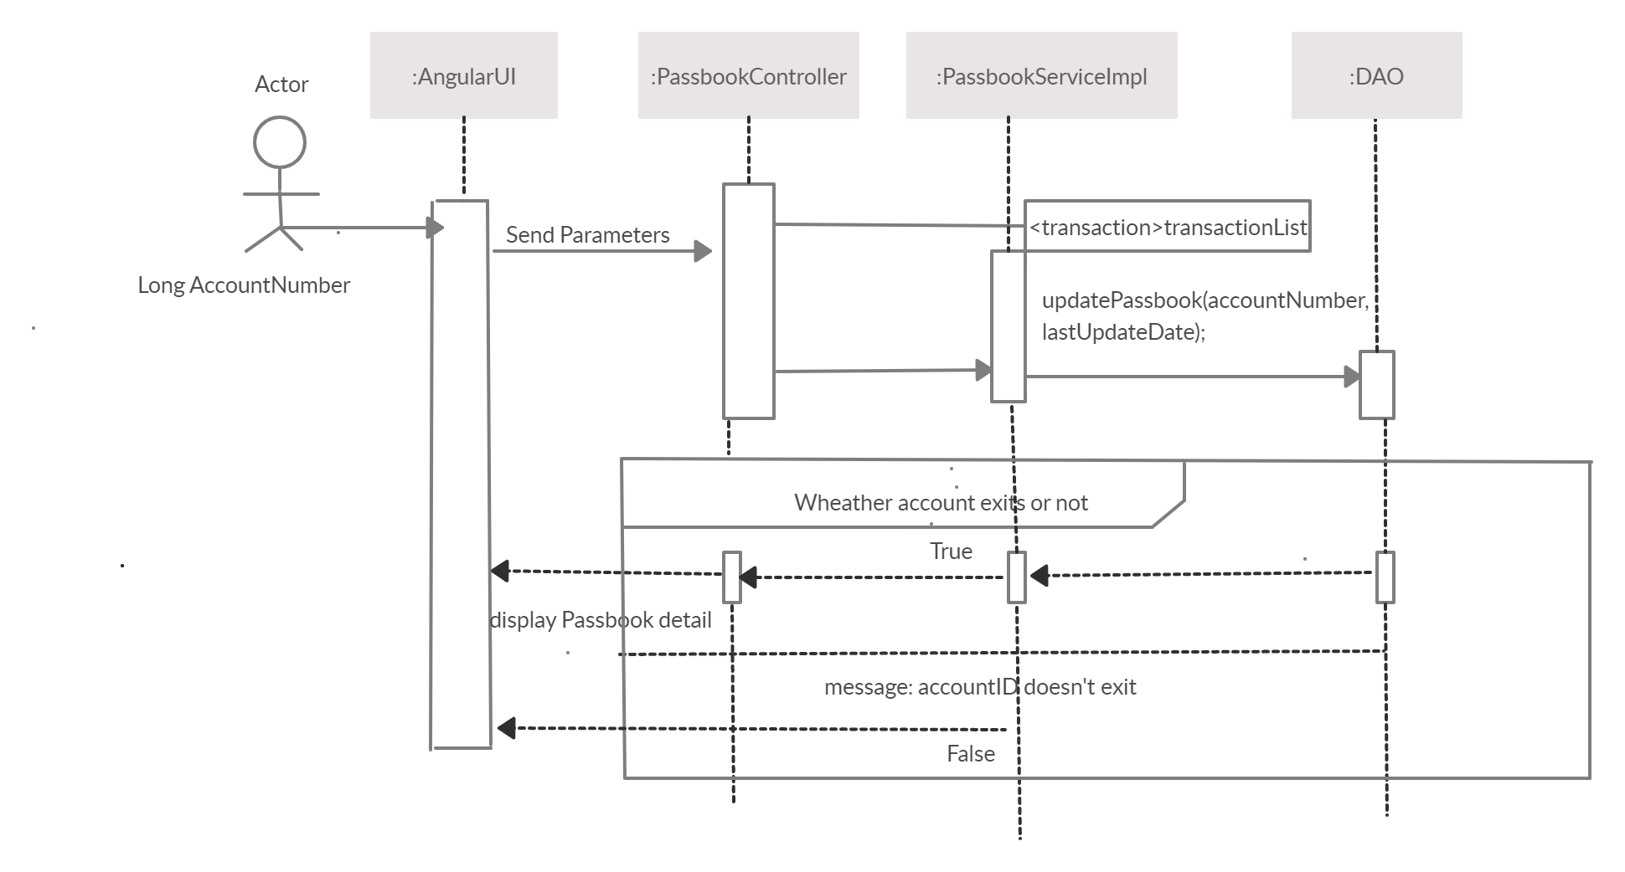

**1.Passbook Update**

This module is designed to show the recent transaction that happened since the passbook was updated the last. It accepts the account number and corresponding to that it show the list of transaction made since the last date of passbook updation.

The form has proper validation.

Validation

Account Id – Must be a 10 digit number.

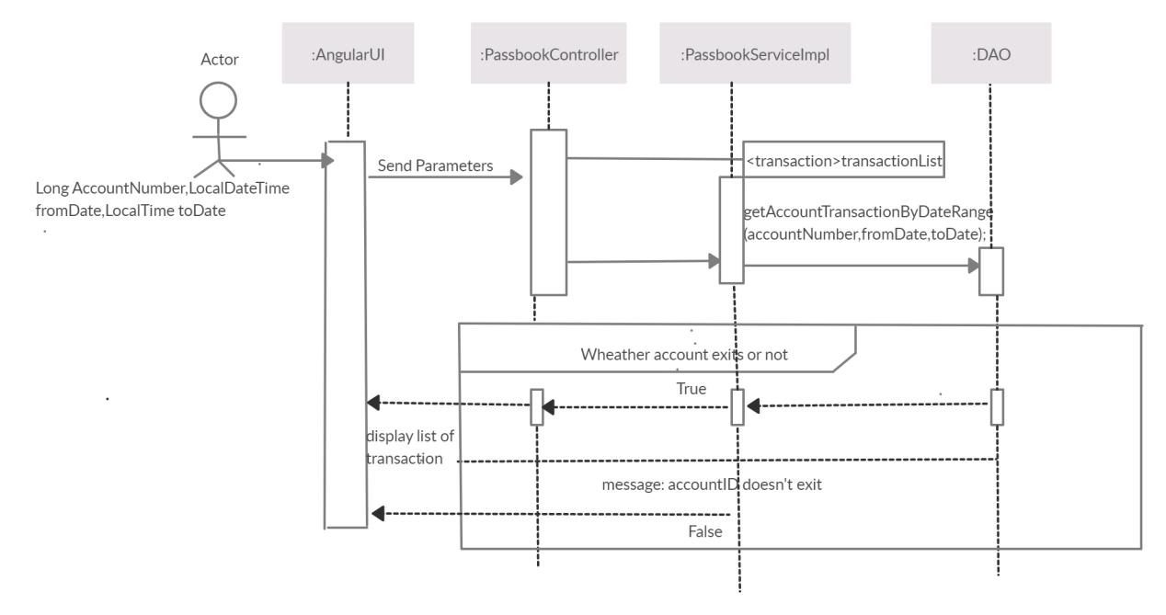

**2.Account Summary**

This module is designed to display the list of transactions made between two given dates. It accepts account number, from date and to date for the range of dates one would like to see the transaction list in the given date ranges.

The form has proper validation.

Validation : All fields are required.

Account Number – Must be a 10 digit number.

From date – must be written in given format or chosen from the calendar.

To date- must be written in given format or chosen from the calendar.To date cannot be greater the current date.

**Passbook Maintenance Class Diagram**

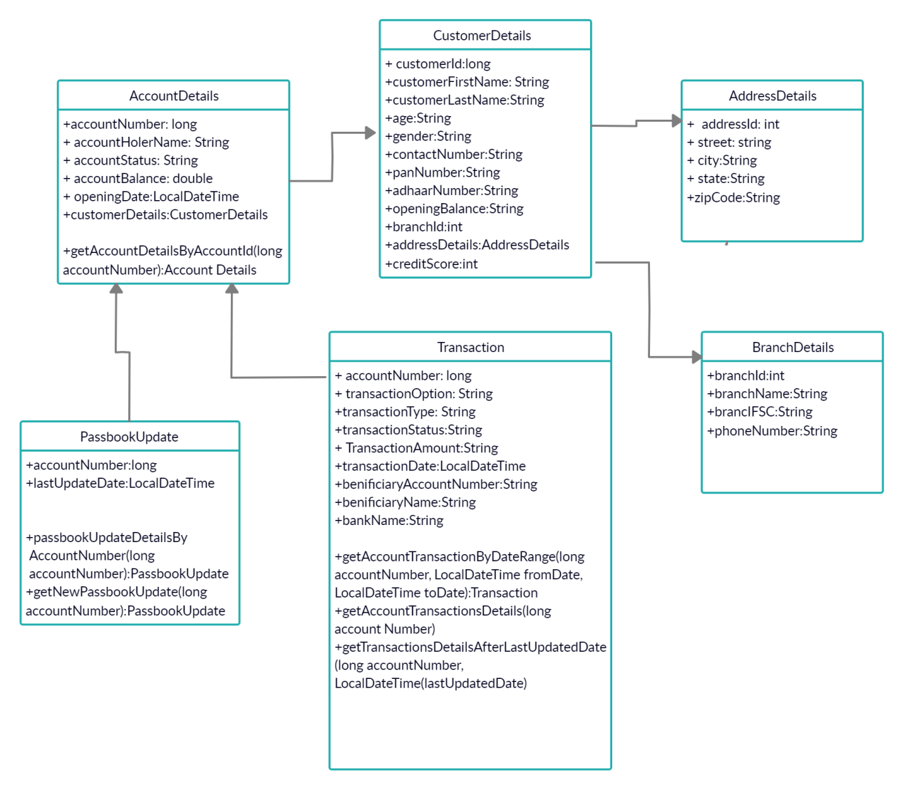

**WebServiceUrlDetails**

**Passbook Maintenance**

**1) get all account Details**

localhost:8080/account/{accountNumber}

localhost:8080/account/1170000011

This url is for fetching all the details of account by account number.

|  |  |
| --- | --- |
| URL | localhost:8080/account/{accountNumber}  i.e localhost:8080/account/1170000011 |
| Method | getAccountDetails() |
| Detail | This url is for fetching all the details of account by account number.  If the account number doesn’t exist it will throw an exception  Account doesn’t Exist.  . |
| Returns | It returns accountDetails, Http status 200 OK.  Account Doesn’t Exist,Http Status 404 Not found |

**2) get all transaction details**

localhost:8080/passbook/transactions/{accountNumber}

localhost:8080/passbook/transactions/1170000011

This url is for fetching all the transactions by the account number.

|  |  |
| --- | --- |
| URL | localhost:8080/passbook/transactions/{accountNumber}  i.e localhost:8080/passbook/transactions/1170000011 |
| Method | getAccountallTransactionsDetails() |
| Detail | 1. This is for fetching all the transactions of a account by the account number. 2. If the account number doesn’t exist it will throw an exception AccountDoesn’t Exist. 3. If there is no transaction for the particular account number then it Will throw TransactionFailedException.   . |
| Returns | It returns , Http status 200 OK.  Account Doesn’t Exist,Http Status 404 Not found.  There is no Transaction,Http Status 404 Not found. |

**3) get all transactions by date range**

1. localhost:8080/transactions/search/{accountNumber}/{fromDate}/{toDate}

localhost:8080/transactions/search/1170000011/2019-04-01T00:00:00.000/2019-07-11T23:59:59.000

This url is for fetching the transactions that are between fromDate and toDate of that particular account Number.

|  |  |
| --- | --- |
| URL | localhost:8080/transactions/search/{accountNumber}/{fromDate}/{toDate}  localhost:8080/transactions/search/1170000011/2019-04-01T00:00:00.000/2019-07-11T23:59:59.0 |
| Method | ggetAccountTransactionsByDateRange() |
| Details | 1. It for fetching the transactions that are between fromDate and toDate of that particular account number. 2. If the account number doesn’t exist it will throw an exception AccountDoesn’t Exist. 3. If there is no transaction for the particular account number in the given time duration then it Will throw TransactionFailedException.   . |
| Return | It returns , Http status 200 OK.  Account Doesn’t Exist,Http Status 404 Not found.  no Transaction in this time duration ,Http Status 404 Not found. |

1. **get all transactions from the last passbook updation date**

localhost:8080/passbook/transactions/{accountNumber}/{lastUpdateDate}

localhost:8080/passbook/transactions/1170000011/2019-05-20T17:38:06.000

This url is for fetching all the transactions from the last update date.

|  |  |
| --- | --- |
| URL | localhost:8080/passbook/transactions/{accountNumber}/{lastUpdateDate}  localhost:8080/passbook/transactions/1170000011/2019-05-20T17:38:06.000 |
| Method | getTransactions() |
| Details | 1. It accepts the account Id and corresponding to that it returns the list of transaction made since the last date of passbook updation. 2. If the account number doesn’t exist it will throw an exception AccountDoesn’t Exist. 3. If there is no transaction for the particular account number in the given time duration then it Will throw TransactionFailedException.   . |
| Return | It returns , Http status 200 OK.  Account Doesn’t Exist,Http Status 404 Not found.  no Transaction in this time duration ,Http Status 404 Not found. |

1. **get passbook update details**

localhost:8080/updatepassbook/{accountNumber}

localhost:8080/updatepassbook/1170000011

This url is updating and returning the passbook update details.

|  |  |
| --- | --- |
| URL | localhost:8080/updatepassbook/{accountNumber}  localhost:8080/updatepassbook/1170000011 |
| Method | getLastUpdatePassbookDetails() |
| Details | It accepts the account Id and corresponding to that it returns the passbookdetails.  If the account number doesn’t exist it will throw an exception AccountDoesn’t Exist.. |
| Return | It returns , Http status 200 OK.  Account Doesn’t Exist,Http Status 404 Not found. |

**Web Application Architecture**

